Define Employee class as per the diagram given below:

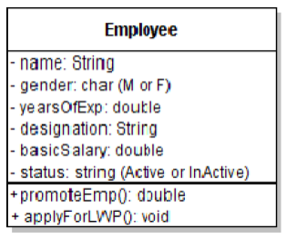

Whenever Employee object gets created, the minimum information to be provided is name and gender. For a fresher, the initial designation will always be ASE and basic salary will be Rs. 10000. However, for an experienced person, when creating Employee object, the years of experience should also be provided. If years of experience is greater than or equal to 3 years, then designation will be ITA and basic salary will be Rs 15000, else set these attributes as that for a fresher.

For any employee created “status” will always be Active initially. The class implements the following behaviors:

1. promoteEmp(): This behavior promotes the employee to the next designation as given below and returns the new salary after promotion: ASE will be promoted to ITA (salary incremented by 5%). ITA will be promoted to AST (salary incremented by 8%). AST will be promoted to ASC(salary incremented by 10%). ASC is the top designation.

2. ApplyForLWP(): This behavior will change the status of employee to InActive and set basic salary to 0